Lab 2: Configuring Static Routes
Objective
The overall objective of this lab is to configure static routes on two routers so that there is a network connection between the computers in the two LANs. You need to configure the network topology, the computer’s IP address, the gateway address, and the IP addresses for the appropriate router interfaces. This requires that the serial connection between routers be configured and enabled. In addition, you also configure static routing between the two networks.
Topology
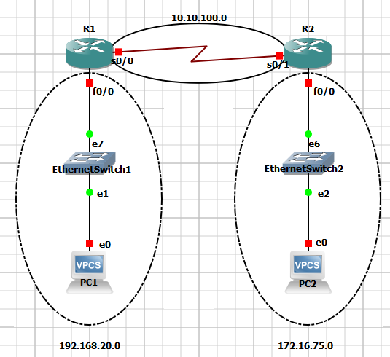
Figure 1: The Network Topology for This Lab
Key Concepts
The following concepts, terms, commands, and steps should have been mastered in this laboratory exercise. Verify your understanding of the material before taking the lab quiz.
1. How do you set the clock rate for the router?
2. Which router controls the clock rate, DCE, and DTE?
3. How do you configure the IP address, subnet mask, and default gateway for the computers in your LAN?
4. How is the gateway address for your LAN router configured?
5. What are the steps to configure the hostname for your router?
6. What are the steps to configure the router interface’s IP addresses and subnet masks?
7. What are the commands to configure a static route from your LAN router to the adjacent LAN router.
8. List two commands that can be used to verify that the routes are configured on the router.
9. Use the computers in your LAN to ping the computers in the adjacent LAN.
10. Use the proper command in the router to trace the route from your router to a host in the other LAN.
11. Use the proper command to make a telnet connection to your router. How do you enable a telnet connection to the router?
12. Use the router command that displays the network routes stored in your router’s routing table.
13. Use the command to save your router configuration to NVRAM.
14. What command is used to verify the routing protocol being used? What are two commands that can be used to display the routing protocol?
Reference Tables
For convenience, Table 1 provides the IP addresses and mask necessary for all interfaces used to complete this lab.
Table 1: Computer IP Addresses, Subnet Masks, and Gateway Address for Lab 2
Computer/Interface – R1 | IP Address | Subnet Mask | Gateway Address
PC1 | 192.168.20.1 | 255.255.255.0 | 192.168.20.250
R1-Fa0/0 | 192.168.20.250 | 255.255.255.0 | ------------------
R1-S0/0 | 10.10.100.1 | 255.255.255.0 | ------------------
Computer/Interface – R2 | IP Address | Subnet Mask | Gateway Address
PC2 | 172.16.75.65 | 255.255.255.0 | 172.16.75.250
R2-Fa0/0 | 172.16.75.250 | 255.255.255.0 | ------------------
R2-S0/1 | 10.10.100.2 | 255.255.255.0 | ------------------
The commands used in these labs are based on the following:
Router: Cisco IOS Version 12.4(7h)
Detailed Lab Steps
In the following tasks, you must demonstrate your knowledge of configuring computer networks. Each task specifies a particular network setting you are required to input. You are required to document the command(s) used to accomplish each task.
Task#1
Configure a static route to the adjacent LAN: LAN-A to LAN-B. Use the IP addresses provided in Table 1. You will be asked to verify that the computers in your LAN can ping the neighbor LAN. Note that a serial interface is used to interconnect the LANs. You must configure routing for both a 192.168.20.0 and 172.16.75.0 networks. A subnet mask of 255.255.255.0 is used. Use 512000 for the clock rate on the serial link (DCE interface).

1. Configure the gateway address for your LAN routers (R1 and R2) according the addresses provided in Table 1. You also need to enable the interfaces. List the commands used to configure the IP addresses, the subnet mask for your gateway, and the command used to enable the interface.
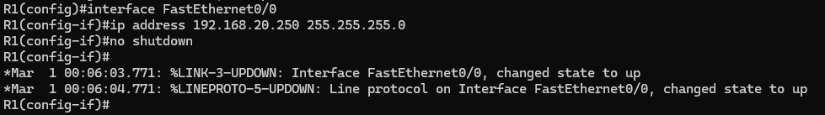
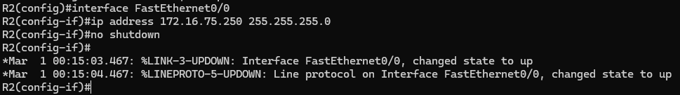
2. Configure the hostname for your routers. R1 should be renamed LAN-A and R2 should be renamed LAN-B. List the router prompt and command used to configure the router’s hostname.
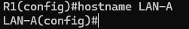
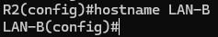
3. Configure the router interface’s serial IP addresses and subnet masks according the addresses specified in Table 1. Use the proper command to verify that the interfaces are properly configured. Set the clock rate on the serial interface interconnecting the two routers to 1536000. List the prompts and the commands used to accomplish this task.
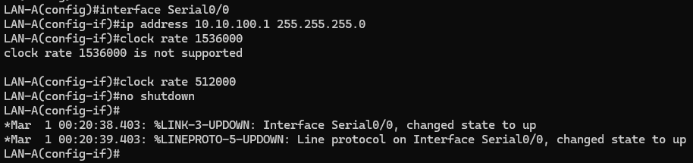
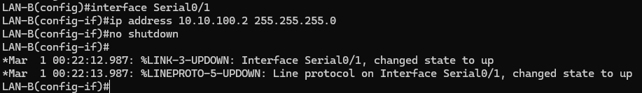
4. Configure static routes from the LAN-A router to the LAN-B router and from the LAN-B router back to the LAN-A router. Use two commands to verify that the routes are configured. List the commands used.

5. What does it mean that the “Gateway of last resort is not set” ?

This message indicates that there is no default route that is configured. There is no route to forward packets if there is no other matching route in the routing table.

6. Use the computers in each LAN to ping the computers in the adjacent LAN.
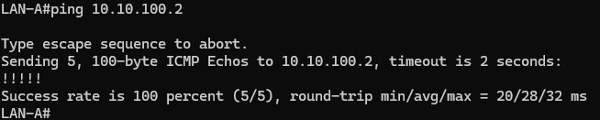
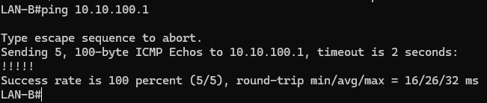
7. Use the proper command to trace the route from a PC in the LAN-A to a host in the LAN-B. Your trace should pass through two routers. List the command used and record the trace information. How many hops did you record?
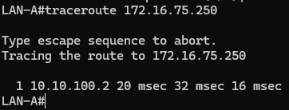
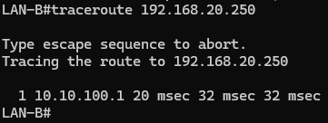

Task #2: Configuration List.

In this task you need to issue the show running-configuration command from the LANA# prompt. The following is a partial list of the items displayed when you issue the command show running-configuration [sh run]. Your task is to define each item and its purpose. You might need to go to Cisco.com to look up what each of these commands means.

1. no service password-encryption
Disables password encryption for plain-text passwords in the configuration file.
2. boot-start-marker
Marker for the beginning of the router’s boot instructions.
3. boot-end-marker
Marker for the end of the router’s boot instructions.
4. enable secret 5 $1$KXED$S08d)zG3x3aiaeFjy7nCP
Stores the encrypted enable password.
5. no aaa new-model
Disables the Authentication, Authorization, and Accounting (AAA) model for login control.

